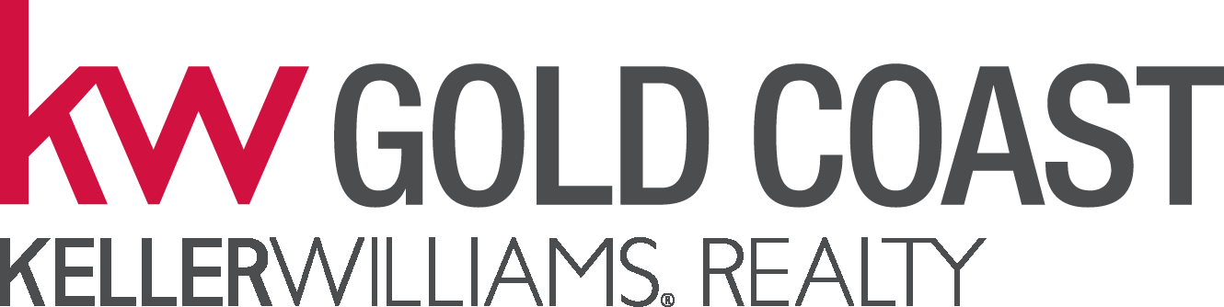
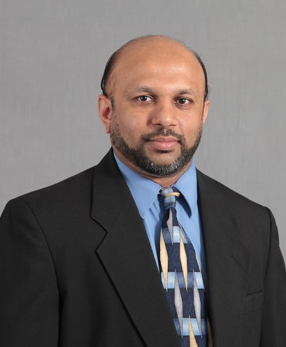
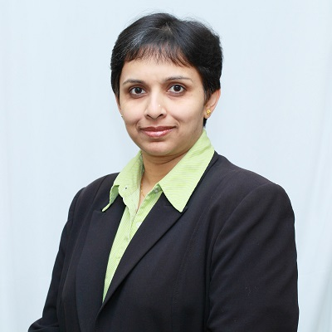
THE ALPHA TEAM
at Keller Williams Realty Gold Coast

Keller Williams Realty Gold Coast
1129 Northern Blvd, Suite 410
Manhasset, NY 11030
O: 516-482-0200
F: 516-482-0250
Each Office is Independently Owned and Operated

UMEMA HASSUJI
Real Estate Salesperson
C: 646-472-9394
HASSAN HASSUJI
Real Estate Salesperson
C: 646-472-9393
Email: umemahassuji@yahoo.com
Email: hhassuji@gmail.com
www.umemahassuji.kw.com

If your property is listed with another broker, this is not a solicitation

WE JUST LISTED TWO MORE!

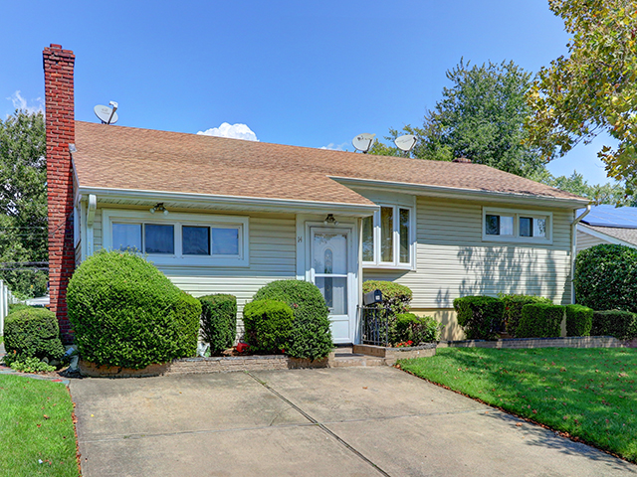
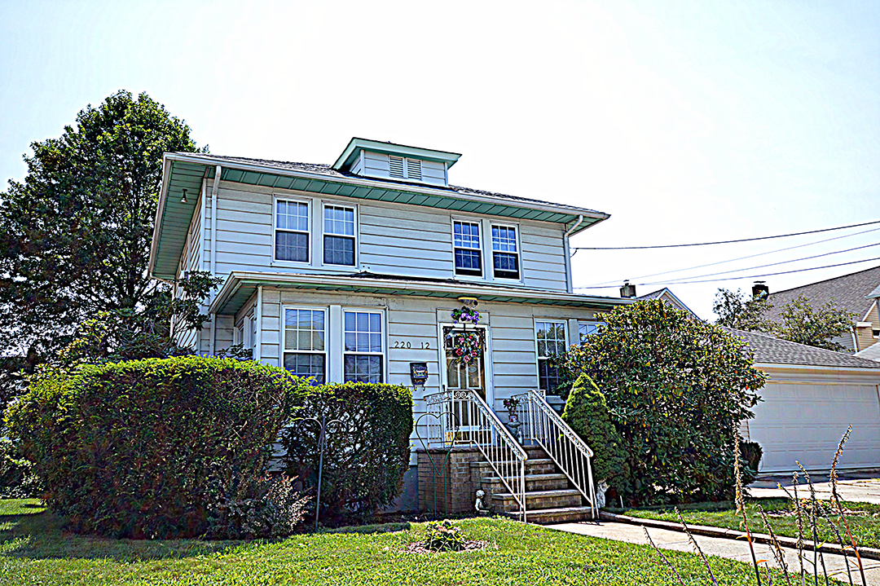

14 EASTWOOD LANE, VALLEY STREAM, NY 11581

Call us now for a COMPLIMENTARY
MARKET ANALYSIS of your home
C: 646-472-9394
C: 646-472-9393

220-12 93rd ROAD,
QUEENS VILLAGE, NY 11428
ARE YOU THINKING OF SELLING OR BUYING A HOME?

